**Build a Sample Java Project using Maven**

**Process:**

**Set Up AWS Resources**

Logged in to AWS Management Console.  
• Launched EC2 Instance: (virtual machine - Ubuntu).

And security groups to allowed HTTP (port 80) and SSH (port 22) traffic with instance type - T2.medium and 15Gb disk size and created PPK file.

**Connect to Your EC2 Instance**

•    Used SSH to connect to EC2 instance using the PPK file via Putty as below.

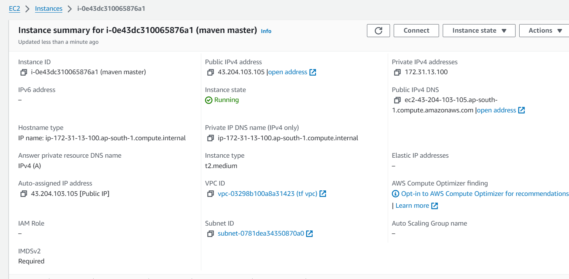

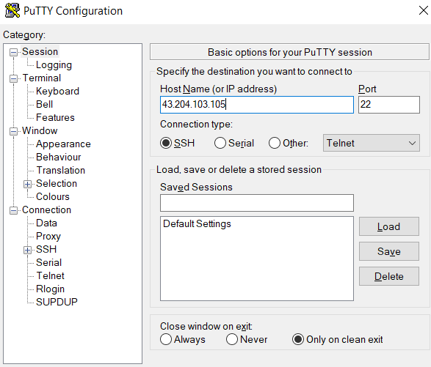

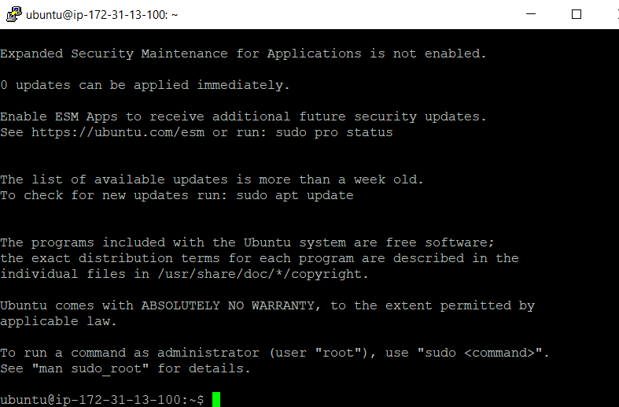

**Installed Java and Maven on to the machine as below:**

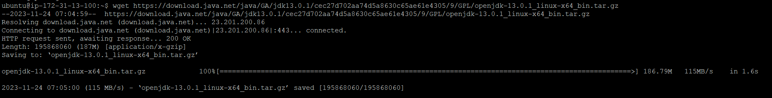

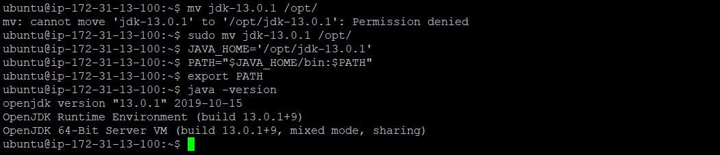

**Checked and verify whether the maven installed or not as below command:**

* Mvn --version

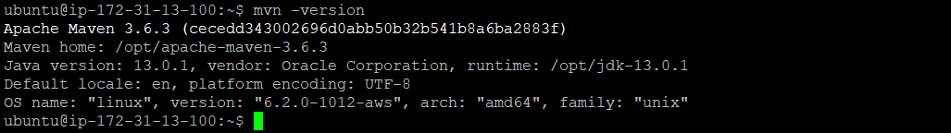

**Now cloned the git repo java code from the github by cloning its repo as below:**

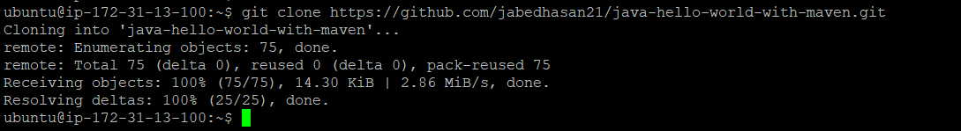

**Now we have human redable code so need to convert it into machine**

**readable so we have to build it using command -** mvn package

**Buildng java project using maven**

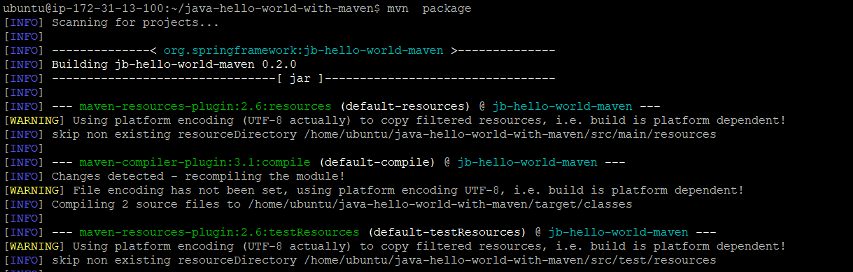

**And after sometime we got the result as build done successfully as below:**

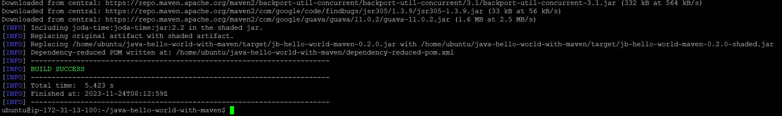

**As soon as you build any java folder/code you will get target folder and jar created inside folder (Artifacts-genrated)**

**after running the jar file we will get final result as below:**

**Coomand : Java -jar <jar file>**

**Result:**



**Git repo:**

<https://github.com/jabedhasan21/java-hello-world-with-maven.git>

**Pom.xml file :**

<?xml version="1.0" encoding="UTF-8"?>

<project xmlns="http://maven.apache.org/POM/4.0.0" xmlns:xsi="http://www.w3.org/2001/XMLSchema-instance"

xsi:schemaLocation="http://maven.apache.org/POM/4.0.0 http://maven.apache.org/maven-v4_0_0.xsd">

<modelVersion>4.0.0</modelVersion>

<groupId>org.springframework</groupId>

<artifactId>jb-hello-world-maven</artifactId>

<packaging>jar</packaging>

<version>0.2.0</version>

<!-- tag::joda[] -->

<properties>

<java.version>1.8</java.version>

<maven.compiler.source>1.7</maven.compiler.source>

<maven.compiler.target>1.7</maven.compiler.target>

</properties>

<dependencies>

<dependency>

<groupId>joda-time</groupId>

<artifactId>joda-time</artifactId>

<version>2.2</version>

</dependency>

</dependencies>

<!-- end::joda[] -->

<build>

<plugins>

<plugin>

<groupId>org.apache.maven.plugins</groupId>

<artifactId>maven-shade-plugin</artifactId>

<version>2.1</version>

<executions>

<execution>

<phase>package</phase>

<goals>

<goal>shade</goal>

</goals>

<configuration>

<transformers>

<transformer

implementation="org.apache.maven.plugins.shade.resource.ManifestResourceTransformer">

<mainClass>hello.HelloWorld</mainClass>

</transformer>

</transformers>

</configuration>

</execution>

</executions>

</plugin>

</plugins>

</build>

</project>

Jenkins file :

pipeline{

agent any

tools {

maven 'maven'

jdk 'java'

}

stages{

stage('checkout'){

steps{

checkout([$class: 'GitSCM', branches: [[name: '*/master']], extensions: [], userRemoteConfigs: [[credentialsId: 'github access', url: 'https://github.com/sreenivas449/java-hello-world-with-maven.git']]])

}

}

stage('build'){

steps{

bat 'mvn package'

}

}

}

}